Compass MED D - Electronic EOBs

General Information
Opt In/Out of Electronic EOB - Through Compass
Opt-In for Electronic EOBs - Through Caremark.com
Opt-Out of Electronic EOB - Through Caremark.com
Beneficiary Did Not Receive Electronic EOB Email
Beneficiary Needs Assistance Updating Electronic EOB Email or Password
Paperless EOB Pop-up on Caremark.com
FAQs
EOB Guest Preview and Paperless Opt-in
EOB 1 Click Paperless Preference Setting and Opt-in
Related Documents

Description: This document covers the functionality present and to be introduced on Caremark.com and Compass, including digital paperless Explanation of Benefits documents (EOB’s or eEOB’s) for MED D and related major adoption campaigns that could cause a beneficiary to call into Care.

General Information

When MED D beneficiaries for paperless EOB clients call into MED D Customer Care, beneficiaries will be allowed to opt into receiving paperless EOBs.

- Beneficiaries can call to opt in to receive paperless EOBs at any time.
- Beneficiaries can call to opt out at any time if they had previously opted in (via Care, Portal).

If beneficiary wants to opt into paperless EOBs, CCRs should follow the steps in Opt in through Caremark.com. However, if the beneficiary wants to enroll in paperless EOBs themselves at a later time, CCRs should assist the beneficiary through Opt in through Caremark.com process outlined below.

Paperless EOBs are available for all clients, except Aetna MA, BSC, and CarelonRx.

Top of the Document

Opt In/Out of Electronic EOB - Through Compass

Note: In order to opt-into paperless EOBs, the beneficiary must have an Email on file in Compass.

The CCR should perform the following:
Step | Action
1 | Are you interested in switching to paperless EOB or paper EOB statements today?
1 | If beneficiary says… |  | Then…
1 | Paperless |  | Do you have an account on Caremark.com?
1 |  |  | If… | Then…
1 |  |  | Yes | - Great. It will only take a minute to request the change.  - We’ve already loaded up to 36 months of your EOB history to your Caremark.com account and you can begin to access them immediately.  - Once we’ve processed your paperless EOB request, you will receive an email each time a new statement has been posted to your account.  - If at any time you wish to opt-out of paperless statements, you can change your preferences in your Caremark.com account profile.  Proceed to Step 2.
1 |  |  | No | - Ask the beneficiary to provide their Email address.  - Update their Compass account with the Email address. Refer to Compass MED D - Email and Phone Number Changes.  - Ask the beneficiary if they are registered.  - If Yes, proceed to Step 2.  - If No, proceed to Quick Registration and Comeback to Caremark.com  Note: Beneficiary needs to have a Caremark.com account to access their EOBs.
1 | Paper |  | - Great. It will only take a minute to request the change.  - You will receive paper EOB statements by mail.  - Since we’re on the phone, let me check to make sure we have the correct address on file.  - If at any time you wish to opt-in to paperless statements, you can change your preferences in your Caremark.com account profile.  Proceed to Step 2.  CCR Process Note: Obtain beneficiary mailing address to mail EOBs to beneficiary.
2 | Confirm we have the correct email address on file for the Beneficiary in Compass.
2 | If... |  |  |  | Then...
2 | Yes |  |  |  | Move to step 3.
2 | No |  |  |  | Refer to Compass MED D - Email and Phone Number Changes for instructions on how to add the email address to their profile.  Move to Step 3.
3 | From the Member Snapshot Landing Page, navigate to the Quick Actions panel, then click the Communications hyperlink.  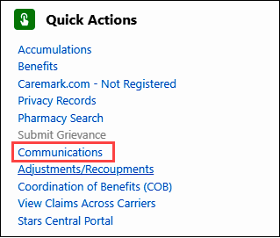  Result: Communications Quick Links screen displays.
3 | If beneficiary opting into... | Then...
3 | Paperless EOBs | Navigate to the Medicare D EOB Preference section.  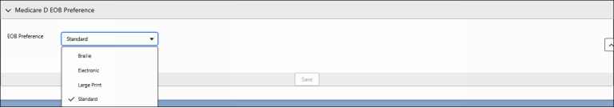  - From the EOB Preference dropdown, select Electronic.  - Click Save.  Note: If an email address is not on file, an error message will pop up to update the email.  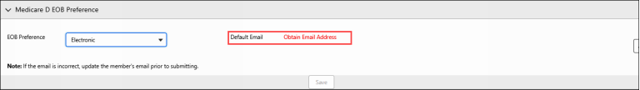
3 | Paper EOBs | Navigate to the Medicare D EOB Preference section.  - From the EOB Preference dropdown, select Standard.  - Click Save.

Top of the Document

Opt-In for Electronic EOBs - Through Caremark.com

The CCR should perform the steps below:
Step | Action
1 | Do you have an account on Caremark.com?  Note: In order to opt-into paperless EOBs, the beneficiary must have an Email on file in Compass.
1 | If beneficiary says… | Then…
1 | Yes | - Great. It will only take a minute to request the change.  - We’ve already loaded up to 36 months of your EOB history to your Caremark.com account and you can begin to access them immediately.  - Once we’ve processed your paperless EOB request, you will receive an email each time a new online EOB has been added to your account.  - If at any time you wish to opt-out of paperless statements, you can change your preferences in your Caremark.com account profile.  Proceed to Step 2.
1 | No | Proceed to Quick Registration Workflow in Quick Registration for Caremark.com.
2 | You will need to log into Caremark.com.
3 | Once on Caremark.com click on Plan & Benefits from the Main Navigation Header. Then, from the drop-down menu, click on Plan Benefits Documents.  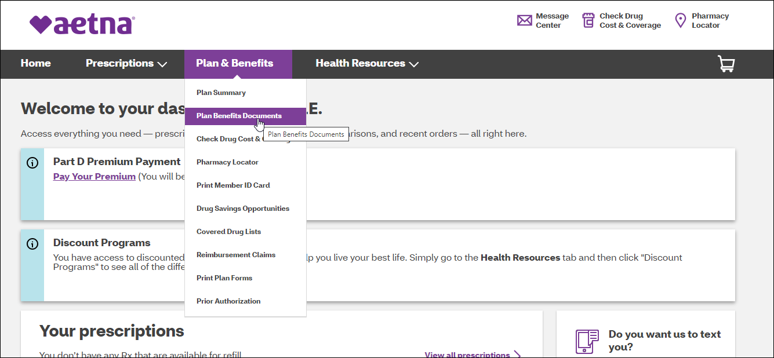
4 | The Plan benefit documents page displays. Click Continue.  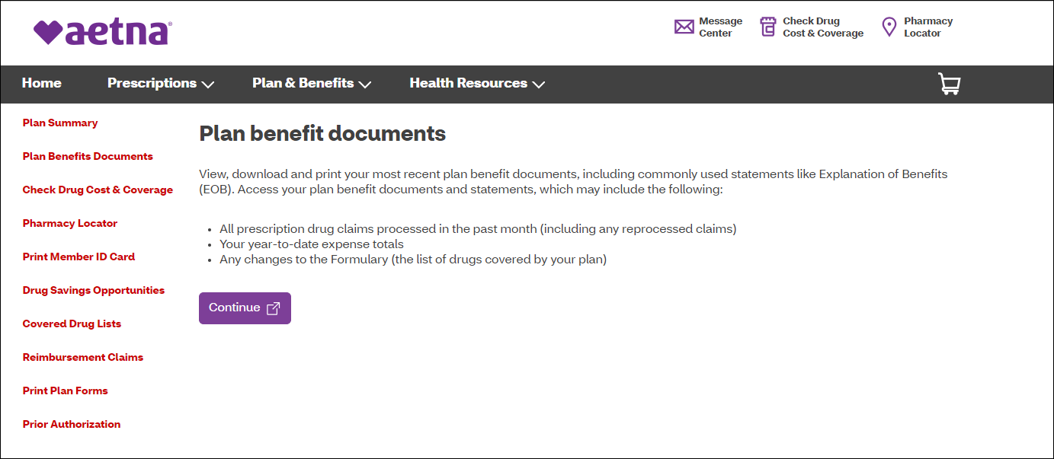
5 | We need your consent. Do you wish to continue? Select Yes.  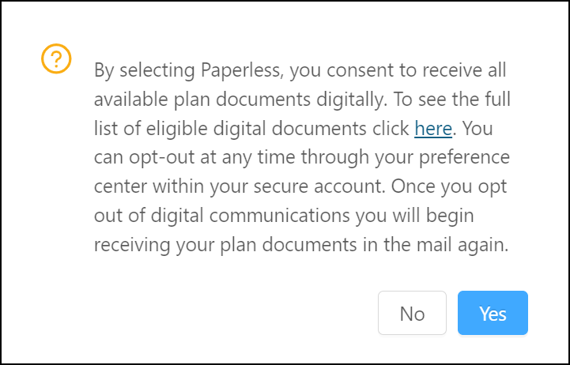
6 | Result: After completing the registration, the following displays showing EOB history with links to view and download PDF files for EOB statements for up to 36 months (3 years) of past beneficiary history.  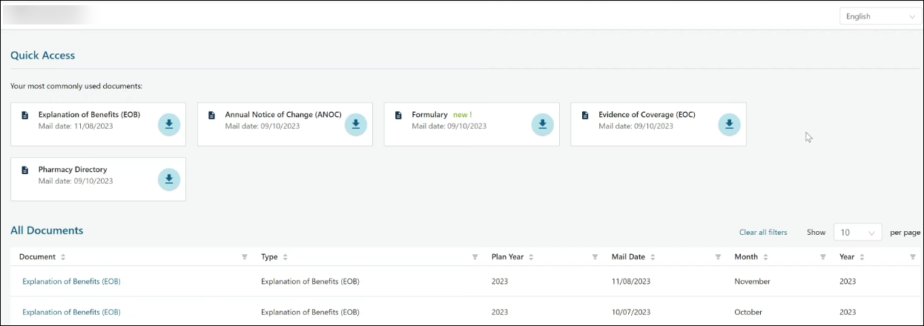  Account Features:  - Additional documents such as Annual Notice of Change (ANOC), Formulary, Evidence of Coverage (EOC), and Pharmacy Directory are available  - Manage print preferences and account settings.  - “Quick access” most recent copy of documents.  - Member can request a hard copy “Need a copy sent to you in the mail?”
7 | There are additional methods to opt-in for paperless EOBs on Caremark.com. Once on Caremark.com, click on Profile at the very top of the page.  Note: Beneficiary can also go to Update communication preferences from the Promo Important Message on the Homepage.  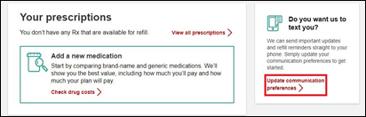  Note: Promotions and prompts may vary by beneficiary.
8 | On the Profile page, select Communication Preferences.  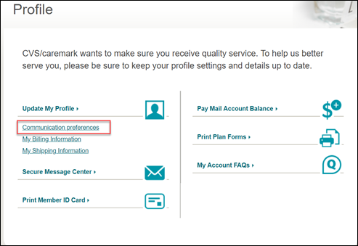
9 | On the Communication Preference page:  - Go to Paperless Setting and Click on Edit.  - Select Show all available documents.  - Select Explanation of Benefits checkbox.  - Select Save Changes.  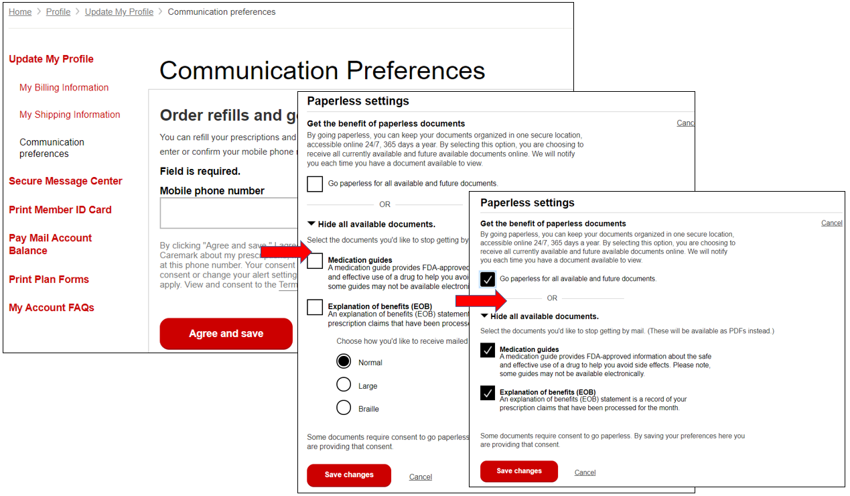

Top of the Document

Opt-Out of Electronic EOB - Through Caremark.com

The CCR should perform the steps below:
Step | Action
1 | Do you have an account on Caremark.com?
1 | If beneficiary says… | Then…
1 | Yes | Proceed to Step 2.
1 | No | Proceed to Quick Registration Workflow in Quick Registration for Caremark.com.
2 | You will need to login to Caremark.com.
3 | Once on Caremark.com, click on Profile at the top of the page.  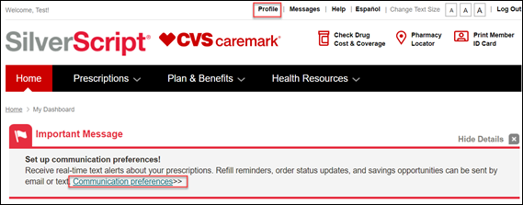
4 | Once on the Profile page, click on Communication preferences.  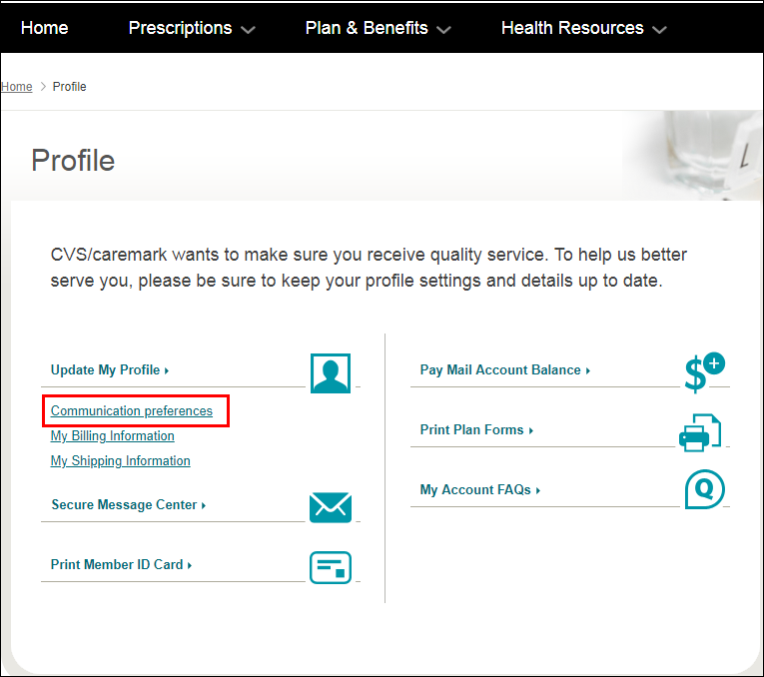
5 | - Scroll down to Paperless settings, then click Edit.  - Select Show all available documents.  - Uncheck Explanation of Benefits checkbox.  - Select Save Changes.  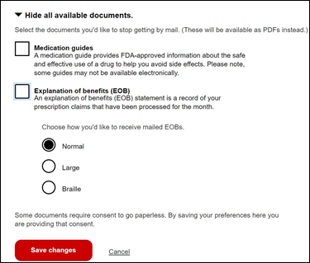  Note: The default print style is Normal however beneficiaries will be able to change to Large Print or Braille from the Print Style drop down menu as needed.

Top of the Document

Beneficiary Did Not Receive Electronic EOB Email

If the beneficiary advises that they opted-in to Electronic EOB but did not receive the monthly email, the CCR should perform the following:
Step | Action
1 | From the Member Snapshot Landing Page, navigate to the Quick Actions panel, then click the Communications hyperlink.  Result: Communications Quick Links displays.
2 | Click the Other Member Letters hyperlink.  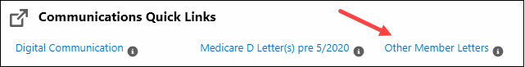  Result: System automatically authenticates and logs the CCR into ONEclick and displays list of available documents.
3 | Confirm the Email Failed text appears beside the MemberID.  Note: If the beneficiary needs to reset their password, click the Reset Password link to send a reset email. This must be done after the updated email has been added to the account.  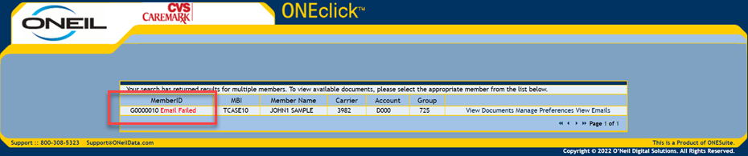  Note: If email failed, a hardcopy is automatically sent to the beneficiary.
4 | Select Manage Preferences to confirm the Email address for the beneficiary is correct under Paperless.  Result:  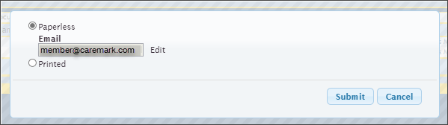  Note: Also confirm we have the correct Email on file in Compass. Refer to Compass MED D - Email and Phone Number Changes.
4 | If the email address is... | Then...
4 | Incorrect | Click Edit and enter the correct Email address.
4 | Correct | Click Cancel.
5 | Click Submit.

Top of the Document

Beneficiary Needs Assistance Updating Electronic EOB Email or Password

If the beneficiary advises that they opted-in to Electronic EOB and need assistance updating the email address or password, the CCR should perform the following:
Step | Action
1 | From the Member Snapshot Landing Page, navigate to the Quick Actions panel, then click the Communications hyperlink.  Result: Communications Quick Links displays.
2 | Click the Other Member Letters hyperlink.  Result: System automatically authenticates and logs the CCR into ONEclick and displays list of available documents.
3 | Select Manage Preferences to confirm the Email address for the beneficiary under Paperless.  Note: If the beneficiary needs to reset their My Document Source password, click the Reset Password link to send a reset email. This must be done after the updated email has been added to the account.  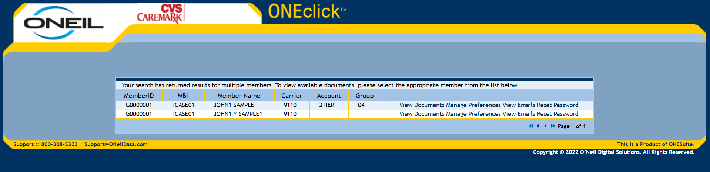
4 | Select Paperless and Click Edit to enter the correct Email address.  Note: Also confirm we have the correct Email on file in Compass. Refer to Compass MED D - Email and Phone Number Changes.
5 | Click Submit.

Top of the Document

Paperless EOB Pop-up on Caremark.com

The CCR should perform the following if paperless EOB window pops up on Caremark.com:
Step | Action
1 | If a beneficiary logs in to Caremark.com, who is not opted in for electronic/paperless EOBs, they may be presented with a pop-up shown below, offering paperless EOB option.  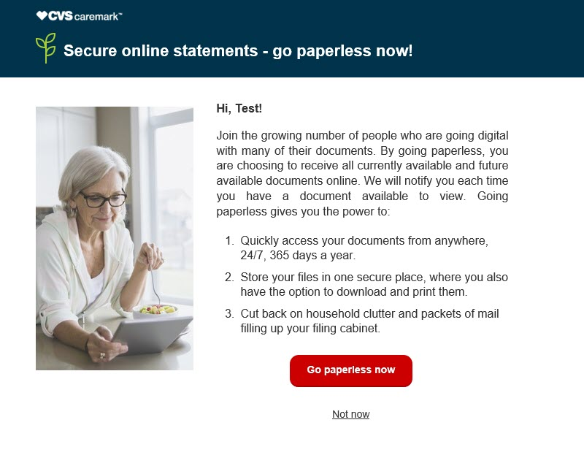
1 | If beneficiary says… | Then…
1 | Yes | - Click on Go paperless now.  - You should now be enrolled in Paperless EOBs.
1 | No | - Click on Not Now.  - The window will close, and you should now be on the Caremark.com dashboard.  Note: An optional survey opportunity regarding paperless options will display for some users. The pop-up window will no longer show to the beneficiary for 30-90 days (this setting varies.)

Top of the Document

FAQs

Use as needed:
Question | Answer
- What are the benefits of switching to paperless EOBs? | - With paperless Explanation of Benefits (EOB) statements, you can access your information online at any time, rather than waiting to receive a paper version by mail.  - We will send you an email as soon as a new EOB is ready to view.  - Paperless EOBs help you stay organized and ensure your personal health information remains secure with no shredding necessary.  - Up to 36 months of your EOBs are stored safely in a password-protected online account and organized by date so you can quickly find the statement you need.  - You can access your statements at any time, and print only those you need, which can reduce paper clutter.  - Since your statements are online, you can access them anywhere – at the pharmacy, at your doctor’s office – even when travelling.
- Can I view my EOBs online even if I am not a paperless beneficiary? | Yes – any beneficiary with a Caremark.com account can view, print or download up to 36 months of EOBs online.
- Can I switch back to Paper Statements? | Yes - You can switch back to receiving paper statements at any time by changing your profile in your Caremark.com account or calling Customer Care.
- How will I know my EOB is available? | - You will receive an email notifying you that a new EOB is available to view online.  - If the email fails and CVS Caremark is notified of the failure, a paper copy email of your EOB will be mailed prior to the end of the month.
- When will I be able to see my EOBs online once I sign up? | - Up to 36 months of your EOB history has already been loaded into your Caremark.com account, and you can login and see those immediately.  - New EOBs will typically be available by the 20th of each month after you use your coverage.  Example: Beneficiary fills a prescription in July. By August 20th, they should receive an email letting them know they have a new EOB available to view online.
- Is this functionality available for the Caremark app or mobile site? | Yes, you can also access your EOBs on the Caremark.com Mobile Site via your phone or other device, however this feature is not available in the Caremark App at this time.
- How far back can I go to obtain EOB statements? | Many beneficiaries can see up to 36 months of EOB history across Caremark PBM plans.
- What if the eEOB functionality is not available when I log in? | I’ll need to submit a request to research this issue. The Web Support Team will be contacting you with a resolution. Are there any benefit issues I can assist you with?  CCR Process Note: Refer to  - Caremark.com – Web Error Form Process (Commercial and MED-D)  - Caremark.com - Web Error Form Process (Vendor Teams Only)
- Why do I have to provide my Email address? | - We will use your email address to send a notification when a new EOB is available to view online.  - If we are unable to deliver an email to the address on record, you will still be able to access your EOB online but will also receive a printed copy in the mail.
- I see a pop-up notice about electronic EOBs every time I login to my Caremark.com account. Is there any way to stop this from happening? | - The pop-up is automated and designed to make it easier to choose paperless Explanation of Benefits statements, should you decide to switch in the future.  - If you do not wish to choose paperless EOBs, simply click the Not now button, and the pop-up will disappear from the screen and be delayed from showing for 30 days or more.
- If I opt out of electronic EOBs on the 19th of the month, do I still receive another electronic EOB on the 20th or is that opt out effective immediately and I’ll be sent a paper copy? | - If you opt out of electronic EOBs on the 1st of the month you will still receive an electronic EOB for that month.  - You will not be mailed a paper one until the next month’s mailing.  Example: You opt out on March 2nd, you will receive an eEOB for March and then receive a paper copy in the mail for April.
- If it’s not immediate, how many days prior to the 20th would the I need to opt out of electronic EOBs in order to receive a paper copy in the mail for that month? | - EOB statements and data are consolidated the first day of each month, for the previous month’s prescriptions.  - Paper vs. eEOB preferences must be updated by the end of the month (30th or 31st) to be made in time for the following month.  Example: You change back to paper preference on January 31st, you will receive a paper EOB for February.
- What if there are issues with the eEOB website? | I’ll need to submit a request to research this issue. The Web Support Team will be contacting you with a resolution. Are there any benefit issues I can assist you with?  CCR Process Note: Refer to  - Caremark.com – Web Error Form Process (Commercial and MED-D)  - Caremark.com - Web Error Form Process (Vendor Teams Only)

Top of the Document

EOB Guest Preview and Paperless Opt-in

Beneficiaries can use the EOB Guest Preview when they receive an email alert. The beneficiary will need to verify their identity by entering their date of birth and their member ID.

Beneficiary does not need to be registered to preview their EOBs on Caremark.com.

Result: The Beneficiary EOB page and EOBs will display. The page will contain a paperless option to opt-in.
- If the beneficiary opts-in, they will be presented with further instructions to register an account and/or update communication preference, pending registration status. Confirmation text advises beneficiaries it may take up to 2 months to receive first electronic EOBs as well as capability to change preference back to paper at any time.

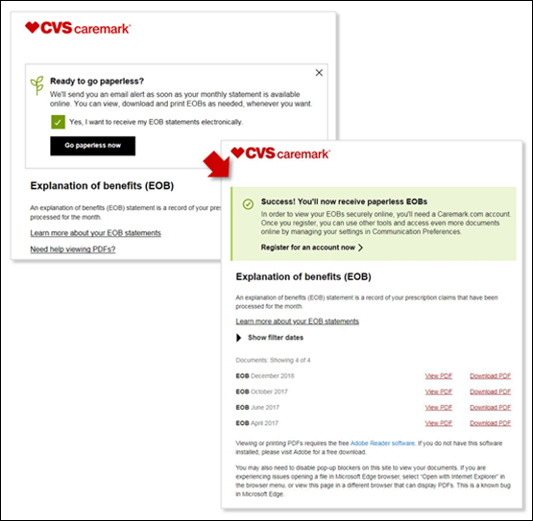

Top of the Document

EOB 1 Click Paperless Preference Setting and Opt-in

Beneficiaries may receive an email that allows them to easily opt-in to paperless EOBs by a simple click on Go paperless now. The beneficiary will be directed to the Caremark.com landing page confirming preference for EOBs has been set. It will provide further instructions to register an account and/or update communication preference, pending registration status. Beneficiary is advised it may take up to 2 months to receive first electronic EOBs as well as capability to change preference back to paper at any time.

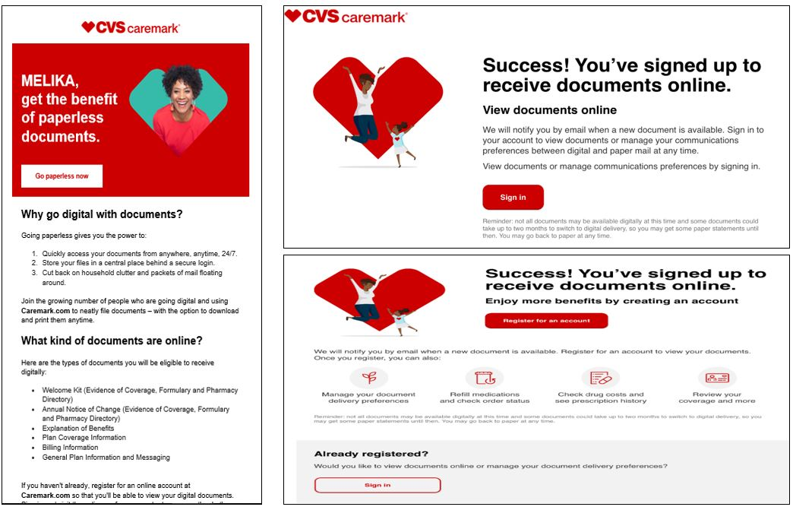

Top of the Document

Related Documents

Parent SOP: CALL-0048: Medicare Part D Customer Care Call Center Requirements-CVS Caremark Part D Services, L.L.C.
Abbreviations/Definitions: Abbreviations / Definitions
Top of the Document

Not To Be Reproduced Or Disclosed to Others Without Prior Written Approval
ELECTRONIC DATA = OFFICIAL VERSION - PAPER COPY = INFORMATIONAL ONLY

